

Cover page,

## Abstract,

## Introduction

## Background

WMO defines an automatic weather station as a facility that automatically transmits or records observations obtained from measuring instruments (WMO, 1992; WMO, 2015). Automatic weather observation refers to the activities involved in converting measurements of meteorological elements into electrical signals through sensors, processing and transforming these signals into meteorological data, and transmitting the resulting information by wire or radio or automatically storing it on a recording medium.

The main functions of an automatic weather station are the conversion of the measurements of meteorological elements into electrical signals through sensors, the processing and the transformation of these signals into meteorological data and the recording and/or the transmission of the resulting information.

These automatic weather stations as they are very valuable and necessary they would not give any value unless they are installed at the proper place. According to World Meteorological Organization (WMO) standard the spacing of weather stations for its representativeness of the given area, must be 1 automatic weather station in each area of 100km2. Abaya Chamo Watersheds covers an area of 19,000km2 and that entails that Abaya Chamo Watersheds needs 190 automatic weather stations.

In this project what the researchers have in mind as a solution is Internet of Things (IOT). The internet of things, or IoT, is a system of interrelated computing devices, mechanical and digital machines, objects, animals or people that are provided with unique identifiers (UIDs) and the ability to transfer data over a network without requiring human-to-human or human-to-computer interaction 1. A thing in the internet of things refers to anything such as an animal or an air craft, in our case it can be a weather station. In IOT there are electronic items that are manufactured to collect data and transmit it. For our problem at hand the researchers has decided to use IOT to come up with the desired result.

## Statement of the problem

Abaya Chamo Watersheds covers an area of 19,000km2 2. According to World Meteorological Organization (WMO) standard the spacing of weather stations for its representativeness of the given area there must be 1 automatic weather station in each area of 100km2 3. However, the active weather stations in Abaya Chamo Watersheds are only, 17 locally installed automatic and non-automatic weather stations . This mean we need 173 more weather stations in the catchment to achieve WMO standard. However the bottleneck is each weather station costs more than 300,000 birr. Based on Technavio's market sizing methodology, the farm automated weather stations market size is predicted to surge by USD 29687.41 thousand from 2021 to 2026 4. Therefore in total the rough estimate will be an astounding 51,900,000 birr to cover the whole 19,000Km2 area. In order to avoid such high amount of expenditure in terms of dollar the scholars involved in the project decided to develop the equipment in-house with a cost less than 30,000 ETB.

## General Objective

To build an automatic weather station that can measure, encode, store and transmit precipitation weather data remotely.

### Specific Objectives

* To investigate and find out the WMO standard for funnel size tipping jar size the orientation of weather station placement.
* To buy the materials needed for the project.
* To build the physical weather station with the funnel tipping jar and an insulator for the electronic materials.
* To integrate and test if the sensor the Arduino and the GSM module can collect, record and transmit it via the internet.
* To test if the automatic whether station resist the harsh weather that can be found in the wilderness.
* To asses and find out areas to place the automatic weather stations in the catchment area
* To place a couple of the weather stations built from the project and asses the impact of the weather stations.

## Significance of the project

The project helps thousands of people and the economy of the country. For the first and for most the project will save hard currency we ought to spend to buy the automatic weather stations from countries that produces it. Furthermore, we will start a good track to mass produce the automatic weather stations ourselves and sell it. Finally, it plays a significant role to alleviate the scarcity of weather data for researchers and weather forecasting applications throughout the country.

## Scope

The project covers developing a prototype for an automatic weather station. This involves a system that can collect rain fall from the atmosphere, interpret it digitally, store the collected data and finally be able to transmit to the cloud. In addition to that be able to process two tasks at the same time i.e. collecting and sending the data to the internet. Finally, be able to utilize minimum amount of power and recharge its batteries from renewable energy such as solar energy.

## Limitations

This project will not be able to mass produce the equipment in mind. Rather it will only show the possibility of making the product with significantly chip equipment that can be available in the country. And therefore it will only be possible to install one weather station for the sake of demonstration.

## Review of related literature

In this project the researchers tried to investigate areas in which Internet of Things (IOT) can be applied. Each of these papers are outlined and investigated.

In the research paper intitled “Practical Application of Internet of Things in the Creation of Intelligent Services and Environments” the author Zhihan Lv outlined that The practical application of IoT has helped to realize the intelligent drive in many fields of society .

## Methodology material and methods

The project is will reverse engineer an already built automatic weather station. Our primary source of data will be a weather station that is installed right here in the university. By looking parts and parcels of the installed weather station we will come up with a design that can replicate the results of the industrial automatic weather station.

The atmospheric precipitation tipping bucket allows rain fall to pass through a funnel and land on the tipping bucket. The tipping bucket is installed on a pivot and it tips back and forth by the weight of the rain landing on it. First the mechanical part is will be designed with the standard of 500 cm2 orifice, and resolution of 0.1 mm.

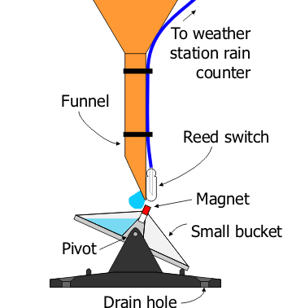

We can divide the wireless weather station in three parts, the mechanical part the electrical part and the software part. Let us examine and outline how to make each of these parts

### The mechanical part

The tipping bucket, the funnel, the supporting structure and its being level all involved in the mechanical part. The mechanics how the tipping bucket transmit data is using a magnet therefore any part of the mechanical part shouldn’t be magnetic. Therefore, the choice of material is aluminum for both the tipping bucket and the inclosing or housing of the instrument.

### The electrical part

The device records how many times the bucket tips and records on its internal memory for 15 minutes. The recorded data will be sent via internet to central station every 15 minutes and wipes off the data from memory for the next recording period. A magnet and the reed switch together tells the system how many times the bucket tipped. The following table shows the electronic item specifications.

|  |  |  |  |  |  |
| --- | --- | --- | --- | --- | --- |
| No | Picture | Name | Quantity | Length | Width |
| 1 | Arduino Mega 2560 Rev3 | Arduino Mega 2560 | 2 | 101.52 mm | 53.3 mm |
| 2 | Buy Magnetic Reed Switch Sensor module at best price online | Reed switch | 1 | 18.5 mm | 15 mm |
| 3 | Real Time Clock RTC DS3231 I2C real -time clock compatible with Arduino and  Raspberry Pi – AZ-Delivery | RTC DS3231 (time keeper) | 1 | 37 mm | 22 mm |
| 4 | CentIoT - Micro SD Mini Storage Board TF Card Reader Memory Shield Module  SPI for arduino DIY Starter Kit : Amazon.in: Industrial & Scientific | Memory reader module | 1 | 46 mm | 24 mm |
| 5 | 161GB Micro SD Card Memory Card Class6 Mobile Phone Memory Card | Memory card | 1 | 32 mm | 24 mm |
| 6 | Arduino DC - DC Voltage Converter Booster Module | DC to DC volt converter | 1 | 21 mm | 85 mm |
| 7 | SIM800L GSM/GPRS Module – FactoryForward India | sim 800l gsm/gprs module | 1 | 25 mm | 23 mm |
| 8 |  | Sim card |  |  |  |
| 9 | ExpertPower EXP12120 12 Volt 12 Amp Rechargeable Battery : Amazon.in: Car &  Motorbike | 12 volt rechargeable battery | 1 | - | - |
| 10 | Rappa's 10 Watt Solar Panel & Stand – Make the Most of the Sun | 10 watt solar panel | 1 | - | - |
| 11 | 4110, 200mm Jumper Wire Breadboard Jumper Wire in Black, Blue, Red, White,  Yellow | RS | Jumping wires | 300 | - | - |
| 12 | Solar Panel Wire 4mm Red – BHG Power Storage Solutions | Solar panel wire | 1 | 5 meters | - |
| 13 | https://www.elecbee.com/image/cache/catalog/Power-Supply-Module/10A20A-PWM-Solar-Charger-Controller-12V-24V-Auto-LCD-Display-Dual-USB-5V-2A-Output-Solar-Regulator-w-1582821-7487-100x100.jpeg | 12v solar controller |  |  |  |
| 14 | https://www.elecbee.com/image/cache/catalog/Display-Screen/Geekcreitreg-1602-Character-LCD-Display-Module-Yellow-Backlight-Geekcreit-for-Arduino---products-tha-978155-3-100x100.jpeg | lcd |  |  |  |
| 15 | Addicore 16-key (4x4) keypad Arduino compatible | Key pad |  |  |  |

### The software part

The two microcontrollers i.e. the Arduino mega should be programmed in order to perform collecting and transmitting the weather data. In our case the weather data is precipitation or rain fall data. The program is written in C language and the Integrated Development Environment (IDE) or Arduino IDE. In addition it is mandatory to get and use the SIM800L_HTTP_connector-1.14.0 driver to be able to use the GSM module to send the data.

## Result and Discussion/Findings

The following circuit diagram shows all the parts of the wireless weather station. The developed system must process two tasks at the same time.

1. The tasks are recording rainfall and
2. transmitting it to the internet.

The developed system will have three parts the electronic part the software part and the mechanical part. Each of these parts will be outlined below and each of them discussed briefly.

### The electronics part

For that reason we have used two Arduino units connected with serial data (SDA) and serial clock (SCL). It is possible to transmit 32 bit of data at a time via this connection. The two Arduino boards are master and slave. The master collects and saves the information on a memory card and then will ask if the slave Arduino is free of work. If the slave Arduino is free the master will send it data. On the other hand the slave Arduino will simply collect the 32 bit data and send it via the GSM module. If work comes from master while sending the slave will send back busy message to master.

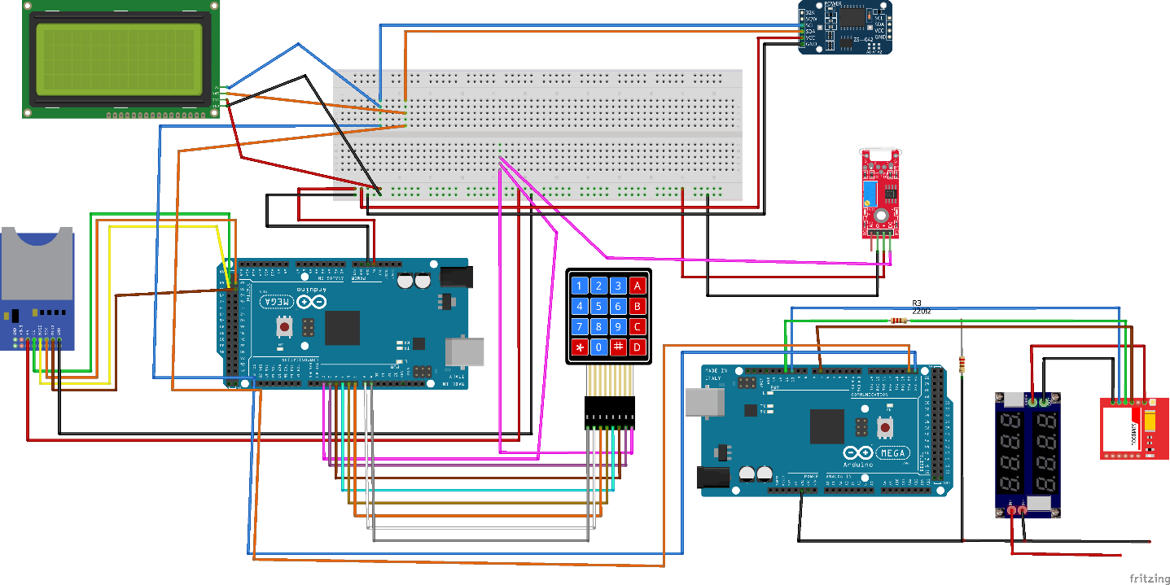

We use SDA and SCL connection to the LCD, DS3231 real time and memory reader to exchange information. The LCD will show the current time and date and will be used to visualize the longitude and latitude information and also the number of files in memory and how many times the bucket has been tipped. The DS3231 will maintain the real time as it has its own battery to operate and this device will return the exact time to the Arduino master whenever it is asked for it. Memory reader will simply save rainfall information and retrieve and return it when requested any or all of the information.

Furthermore the master Arduino has connection with the keypad and the reed switch. The keypad is used to

* input longitude and latitude data
* to display the time on the LCD
* to decide to save or continue with previous setting

finally, the reed switch is used to detect the magnetic field from the tipping bucket. If it tips a magnet will move over the reed switch and therefore the reed switch will trigger a series of action from creating the information to saving it and to transmit it to the internet.

The researchers in the project has finally found out that the items that has been listed in the methodology part as indeed fulfilled the objective of the study. That is to create a working prototype that can record save and finally send rain fall data to the internet remotely.

## The mechanical part

The mechanical part will have the tipping bucket and inclosing body to prevent more rainfall from entering the system. In addition, it needs a funnel to again limit the amount of water entering. Finally, the mechanical part also covers the standing structure to hold the electronic system or hardware. Each of these is shown on the installation pictures below as it is being installed at the demo farm in Arba Minch University Main campus.

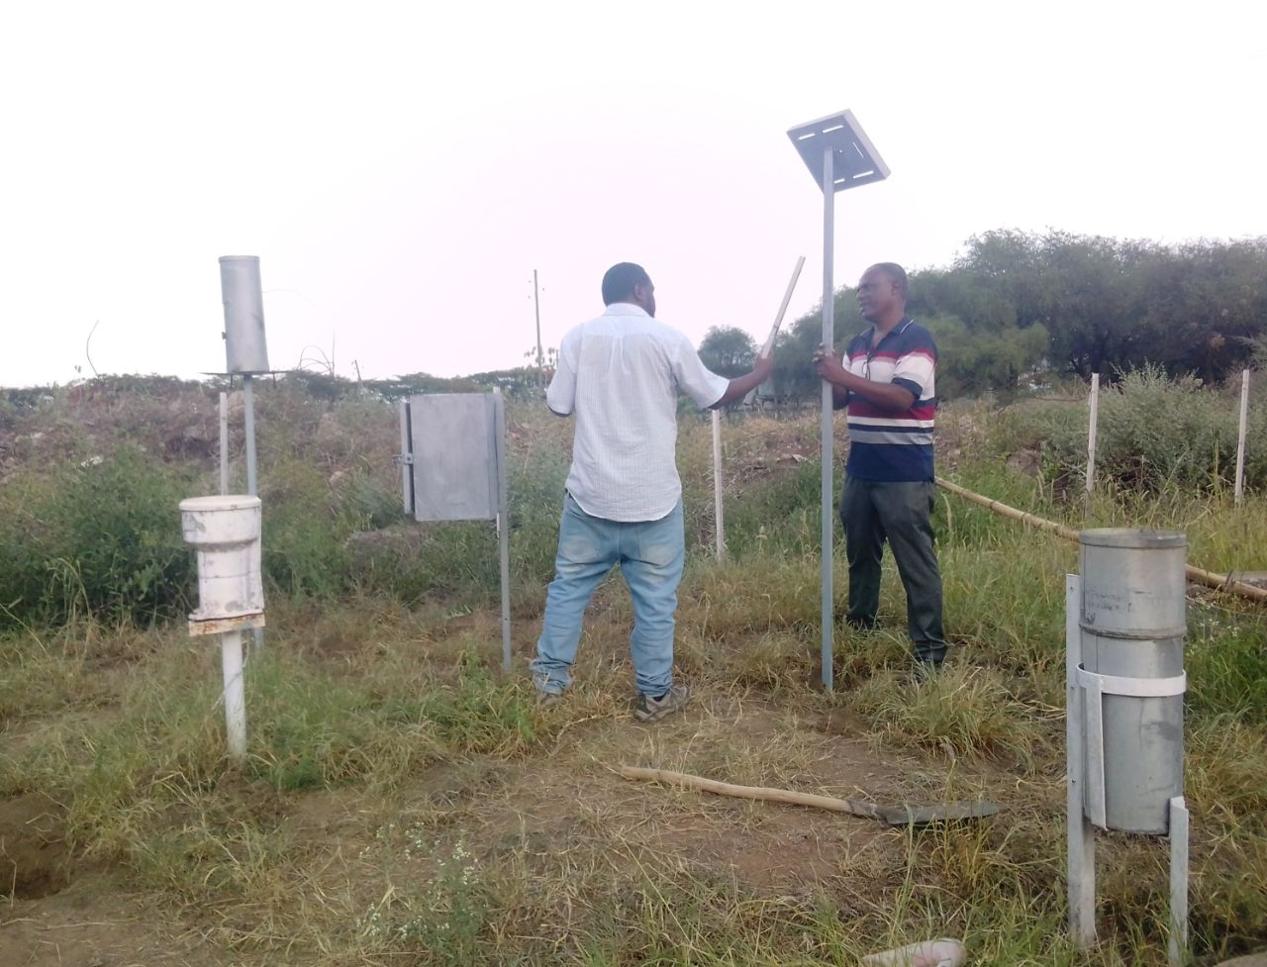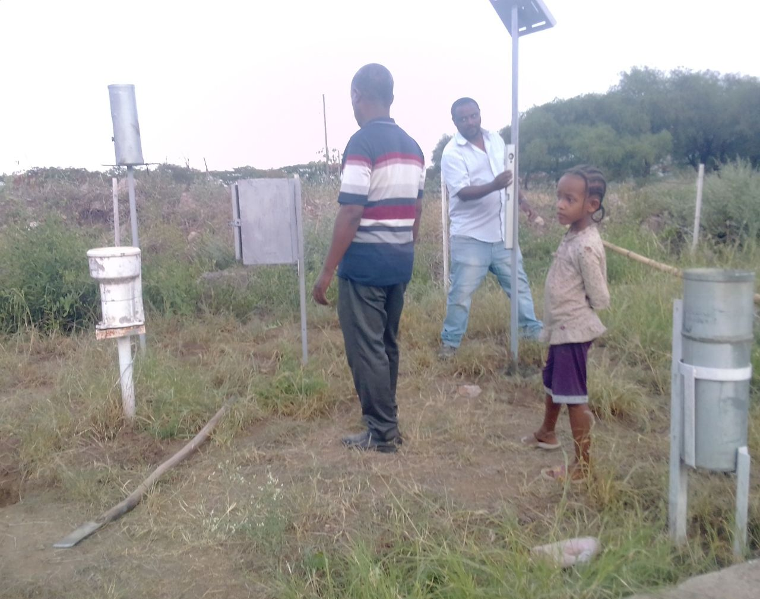

### The Software Part

The software is developed using the Arduino IDE and C programming language. To run this model, we need two different programs, one for the slave and one for the master. The tasks given for the master include

1. accepting information from user via keypad
2. sending display information to LCD
3. requesting time and date information from the RT DS3231 module
4. requesting and saving data on memory module
5. requesting idle or busy information from the slave Arduino
6. reading information from reed switch for rainfall data

On the other program the slave is given the following list of tasks

1. answering idle or busy to the master Arduino
2. initializing the sim800l module and send data to the internet

sample program for both the slave and master is attached at the appenex of the paper.

## Conclusion and Recommendation

As the researchers found out from the project that the objective of creating a wireless weather station from various IOT modules is successful. As this paper shows it is possible to produce a working prototype that can collect rainfall data and transmit it via the GSM network to the remote server. However, the objective in terms of using it for sure on the fields of Ethiopia has not been yet fulfilled. The reason behind is that the prototype is not field or real time installable because of the lose wires and not securely put in properly manufactured housing. Furthermore only a portion of the Arduino boards are used which means it is possible to create a miniature version of the model for practical use.

At last the model produced in this project is only a prototype and therefore the LED and other unused resisters and power regulators on the board will consume power. Therefore, it was not possible to limit and control the power consumed. It is therefore the recommendation of this paper to do more research on the power part of the model and possibilities of making manufacture able version of the proposed or found model in this paper.

Reference

1. What is IoT (Internet of Things) and How Does it Work? - Definition from TechTarget.com. Accessed November 27, 2022. https://www.techtarget.com/iotagenda/definition/Internet-of-Things-IoT

2. Tibebu Kassawmar N, Ram Mohan Rao K, Lemlem Abraha G. An integrated approach for spatio-temporal variability analysis of wetlands: A case study of Abaya and Chamo lakes, Ethiopia. *Environ Monit Assess*. 2011;180(1-4):313-324. doi:10.1007/s10661-010-1790-z

3. Observations - Data - Modelling | World Meteorological Organization. Accessed November 27, 2022. https://public.wmo.int/en/our-mandate/what-we-do/observations

4. Farm Automated Weather Stations Market | Size, Share, Growth, Trends | Industry Analysis | Forecast 2026. Accessed November 27, 2022. https://www.technavio.com/report/farm-automated-weather-stations-market-industry-analysis

Acknowledgment, Declaration